**Name- Pawan Kumar**

**ID- KSPL1241**

**SECTION 1- Multiple choice question’s**

1. D

2. A B C D

3. B

4. C

5. A

6. B

7. C D E

8. D

9. C

10. C

11. D

12. A C D

13. A

14. B

15. B

16. B

17. B

18. B

19. C

20. D

**Section B - Admin Configuration (30 Marks)**

1. **Validation Rules (15 Marks)**

Only Admins should be allowed to change the account owner.

Error Message : "You are not authorised to transfer the account."  **(5 marks)**

SOL-

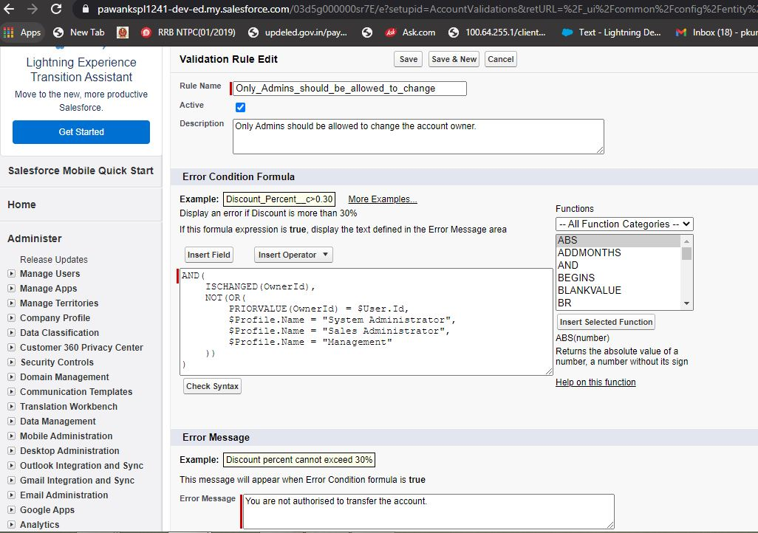

Fig: 1.1 Create validation rule on owner

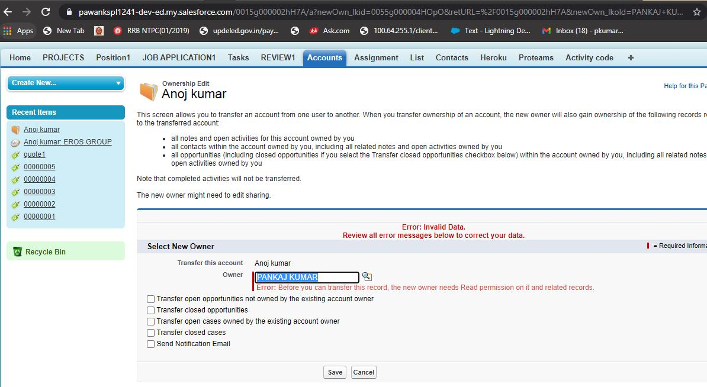

Fig: 1.2 validation rule shows error message on changing account owner

(b) While closing the opportunity ( 'Closed Won') , an Opportunity Line Item should be present. If  opportunity line item is not present under a opportunity ,

it should give the error message "Opportunity Line Item should be present while closing the opportunity."

**Sol-**

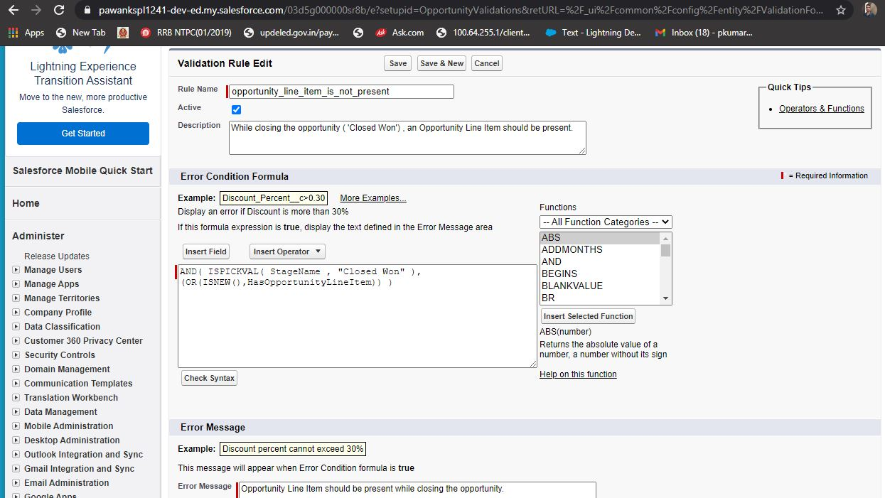

Fig: 2.1 Create validation rule on opportunity closed

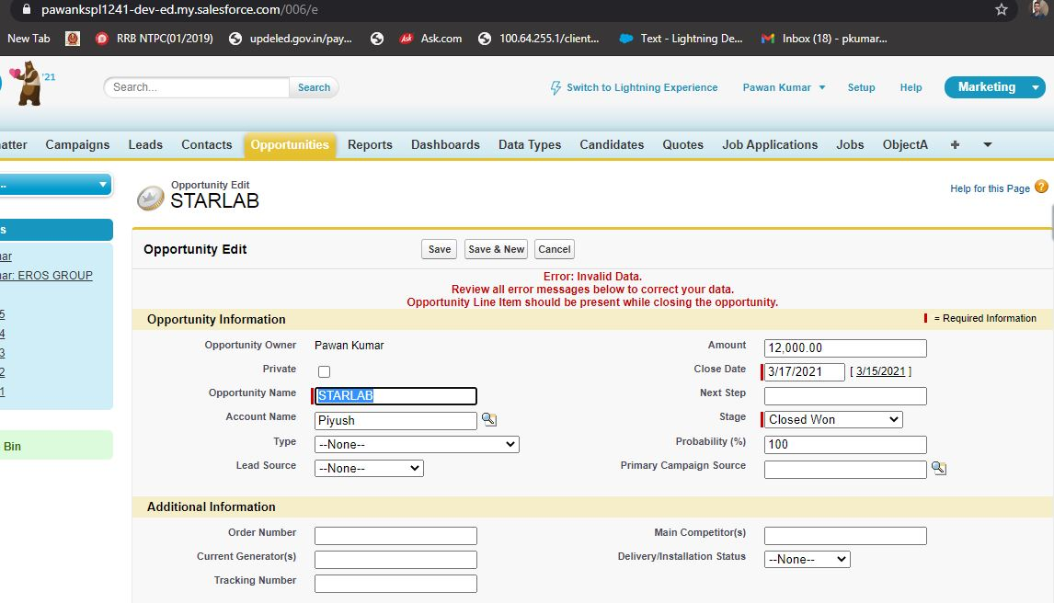

Fig: 1.2 validation rule shows error message on changing stage -closed won

1. **Workflow Rule (5 Marks)**

If Amount > $10,000 send an email alert on opportunity **closed won (Stage field value)** to pgoyal@kloudrac.com and msharma@kloudrac.com

Email Template .

Subject : Deal closed Alert - $Amount - Opportunity Name

Opportunity Name :

Account Name :

Account Owner :

Amount :

Close Date :

Best Regards

Salesforce Team - Kloudrac

**Sol-**

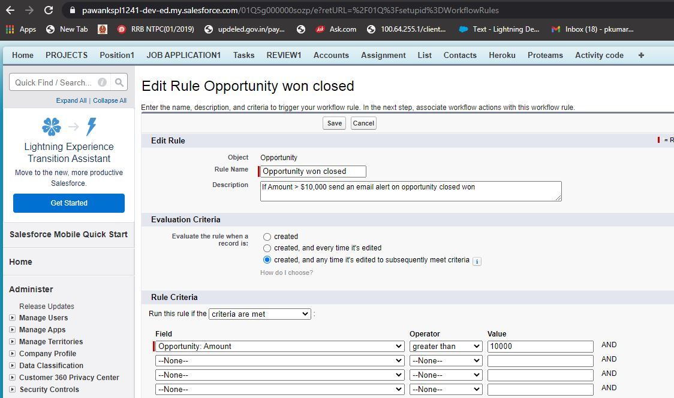

Fig: 1.1 create evaluation criteria on workflow

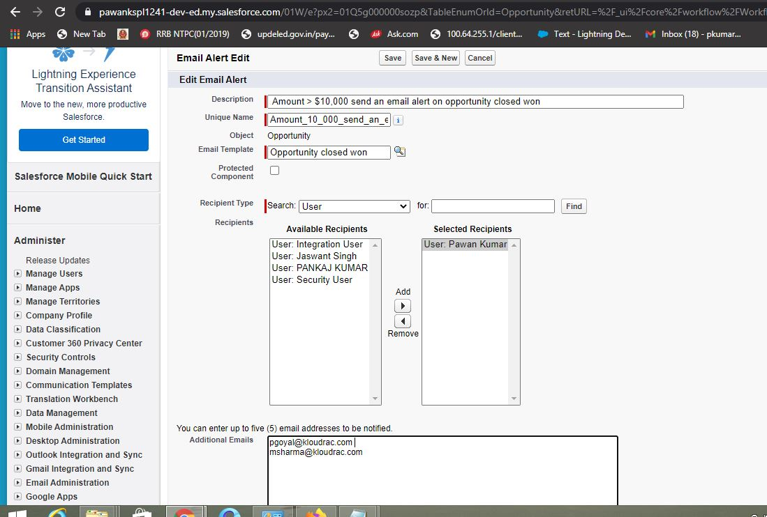 Fig: 1.2 create send mail action on workflow

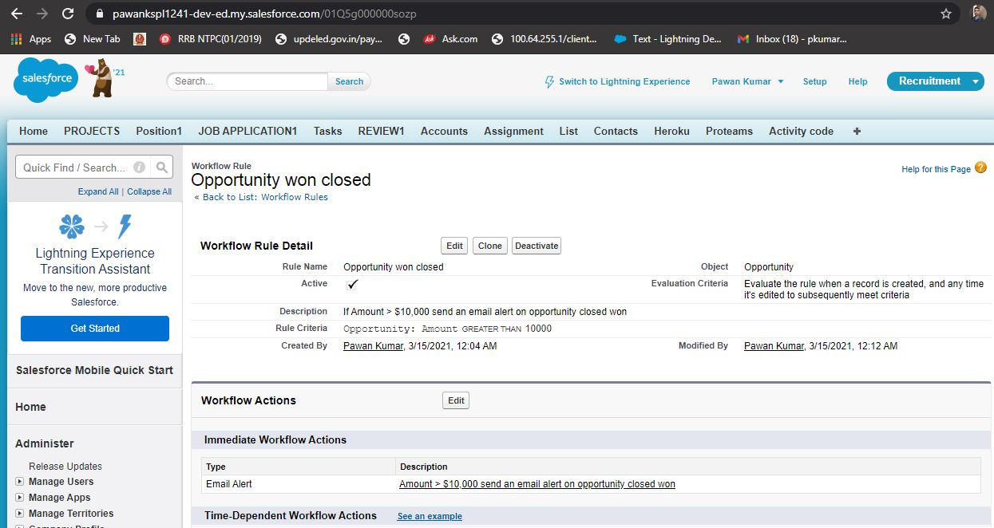 Fig: 1.3 work flow created

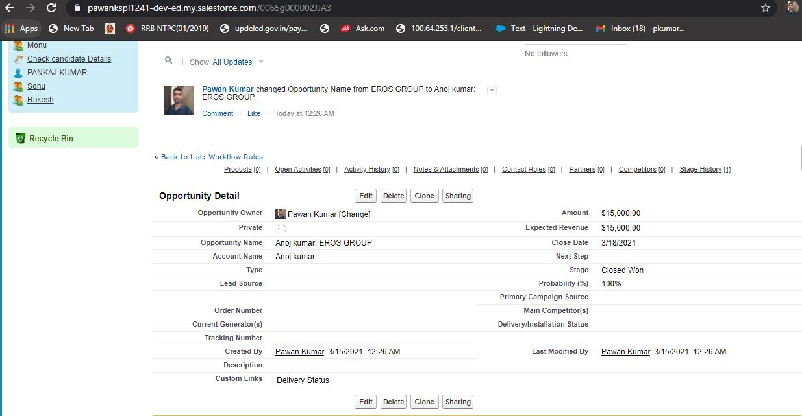

Fig: 1. Opportunity created to fire trigger

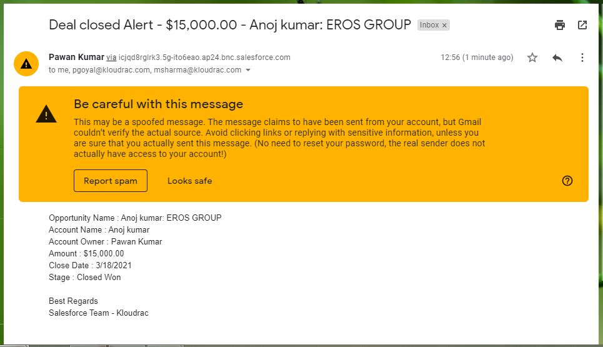

Fig: 1.4 Email sent to users

1. **Triggers**
2. Write a trigger for showing the Quote Line Item count on the related Quote.

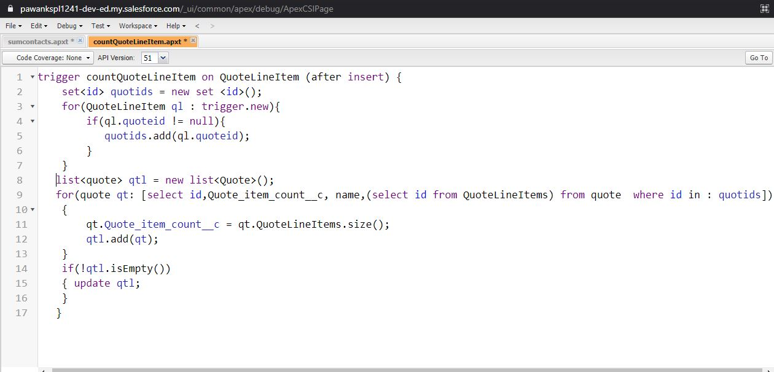

Fig: 1.1Trigger code to create to count quote line items

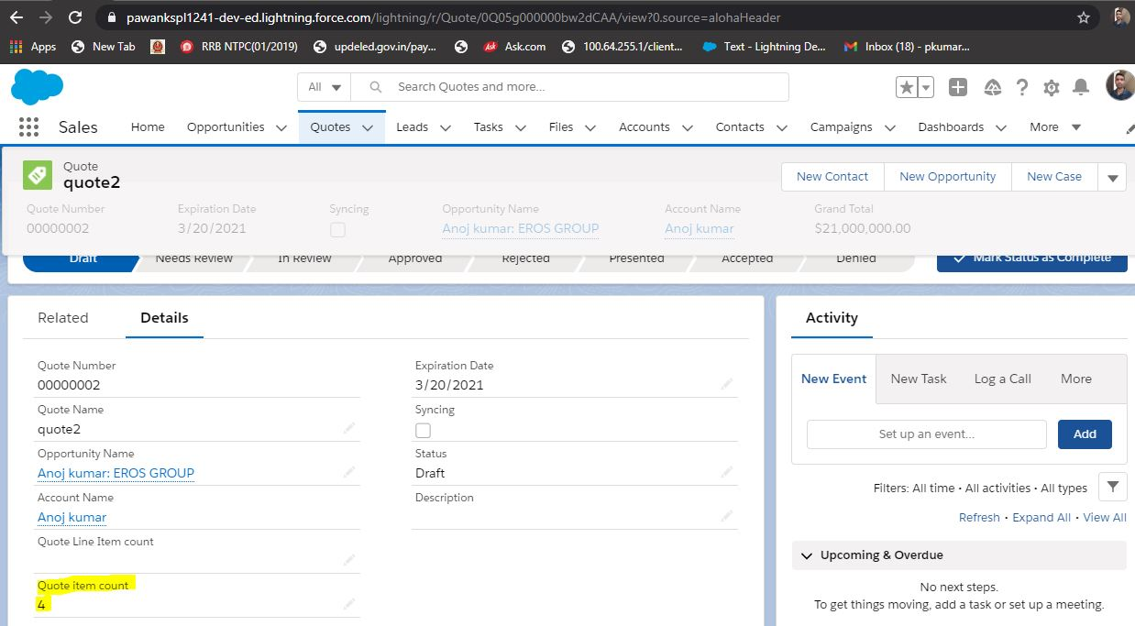

Fig: 1.2 Trigger output